Overview

- Diversified global financial services firm headquartered in New York

- Revenues: $33 billion

- Market Capitalization: $62 billion

- Maintains over 600 offices in 28 countries with 55,700 employees worldwide

- Firm founded in 1935 as J.P. Morgan spun off investment banking unit as a result of Glass-Steagall

- Current firm a result of many mergers including Dean Witter in 1998

- Morgan Stanley operates in four business segments:

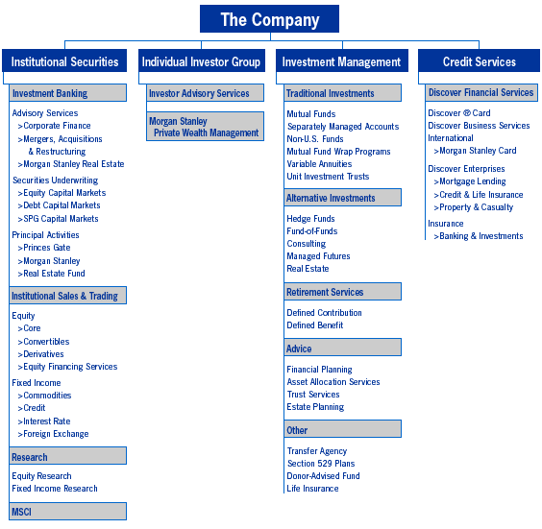

MS Distribution Channels

Institutional Securities
- Direct marketing by investment bankers
- Over telephones by salespeople
- Through electronic trading connections (i.e. – FIX systems)

Individual Investor Group
- Through the firms national financial advisor network
- Over the Internet via Morgan Stanley Online

Investment Management
- Through the firms national financial advisor network
- Through outside mutual fund wholesalers and brokerage houses

Credit Services
- Through telephone call I center
- By direct mailing campaigns
- Over the internet

Recommendations Going Forward

- Divest Ansett Worldwide aircraft leasing business
- Continue to operate business at current scale
- Focus on continuing superior financial performance
- Improve market share across all major businesses
- Positively differentiate the Firm’s reputation and brand
- Ensure the Firm is well-positioned for industry consolidation
- Manage human talent

